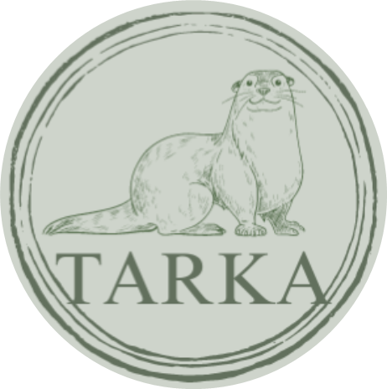
Menu

MENU

LOCALLY SOURCED, FRESHLY MADE

DRINKS & SNACKS

Our food is locally sourced and freshly made to order.

Drinks Small Large
Pot Tea- breakfast, earl grey, mint,
fruit, decaf , green, L&G Pot £2.20

Coffee –
Americano, £2.20 £2.60
Latte, £2.45 £2.90
flat white, £2.30 £2.80
Cappuccino £2.45 £2.90
Mocha £3.00
Hot Chocolate £2.80

Range of cold drinks in the fridge £1.50
Toasted Teacake £2.20
Toast slice £1.00
2 slices £1.50

Breakfast Baps
Bacon Bap £4.00
Sausage Bap £4.00
Sausage & Bacon Bap £4.00
Bap & large hot drink £6.00

Sandwiches/Salads
Pick your Filling freshly cut bown or white:
Ham Cheese Egg Mayo Tuna
Sandwich to eat in, Salad garnish & crisps £6.50
Sandwich to take out £5.50

Toasted Sandwich
Ham, Cheese, Tuna £7.00
Additional toppings 50p
Cakes
We offer a selection of cakes, traybakes and cheesecakes from £2.50-£3.50
Tarka Tea – Scone of your choice and pot of tea
(fruit with Jam & Cream; cheese with cream cheese and chutney) £5.50
Torridge Tea – Half a sandwich and a scone (as above) with a pot of tea £8.00

Pasties & Sausage Rolls £2.50-£3.75

